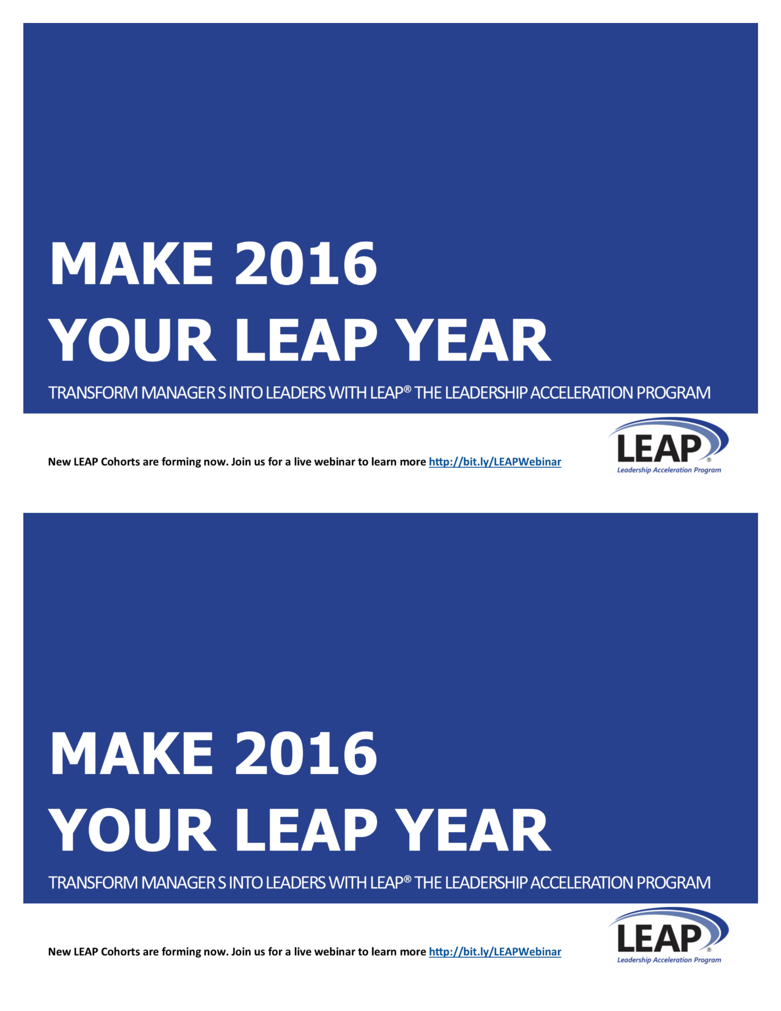

By increasing the leadership confidence and competence of mid-level managers, you can transform your organization with new innovation, accelerated strategy execution, and improved problem solving and results.

LEAP® LEADERSHIP DEVELOPMENT

Designed in 2002, specifically for mid-level managers, LEAP® increases leadership confidence and competence and transforms managers into leaders. I have a new LEAP Cohort forming soon, contact me to find out how to get started.

**CONTACT: [LEAP COACH NAME]**

**[EMAIL]**

**[PHONE]**

**Or find out more at** [**www.xxx.com**](http://www.xxx.com)



By increasing the leadership confidence and competence of mid-level managers, you can transform your organization with new innovation, accelerated strategy execution, and improved problem solving and results.

LEAP® LEADERSHIP DEVELOPMENT

Designed in 2002, specifically for mid-level managers, LEAP® increases leadership confidence and competence and transforms managers into leaders. I have a new LEAP Cohort forming soon, contact me to find out how to get started.

**CONTACT: [LEAP COACH NAME]**

**[EMAIL]**

**[PHONE]**

**Or find out more at** [**www.xxx.com**](http://www.xxx.com)



NAME

COMPANY NAME

ADDRESS

CITY, STATE ZIP

NAME

COMPANY NAME

ADDRESS

CITY, STATE ZIP