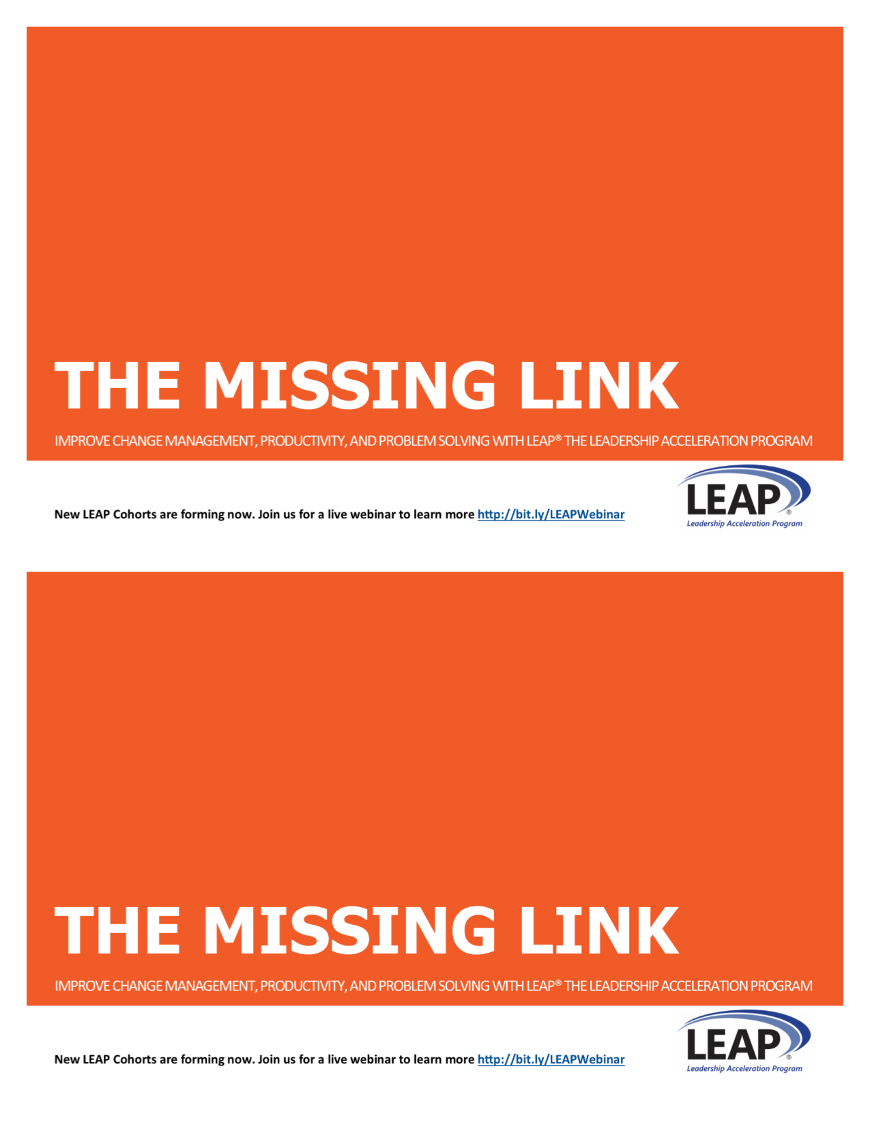

Accelerate execution in your organization. Competent, confident leaders at the mid-level are the key to successful strategy execution.

LEAP® LEADERSHIP DEVELOPMENT

Designed in 2002, specifically for mid-level managers, LEAP® is the Leadership Acceleration Program to help sharpen your competitive edge and help your managers transform into confident, competent leaders. New LEAP Cohorts are forming now, contact me to find out how to get started.

**CONTACT: [LEAP COACH NAME]**

**[EMAIL]**

**[PHONE]**

**Or find out more at** [**www.xxx.com**](http://www.xxx.com)



Accelerate execution in your organization. Competent, confident leaders at the mid-level are the key to successful strategy execution.

LEAP® LEADERSHIP DEVELOPMENT

Designed in 2002, specifically for mid-level managers, LEAP® is the Leadership Acceleration Program to help sharpen your competitive edge and help your managers transform into confident, competent leaders. New LEAP Cohorts are forming now, contact me to find out how to get started.

**CONTACT: [LEAP COACH NAME]**

**[EMAIL]**

**[PHONE]**

**Or find out more at** [**www.xxx.com**](http://www.xxx.com)



NAME

COMPANY NAME

ADDRESS

CITY, STATE ZIP

NAME

COMPANY NAME

ADDRESS

CITY, STATE ZIP