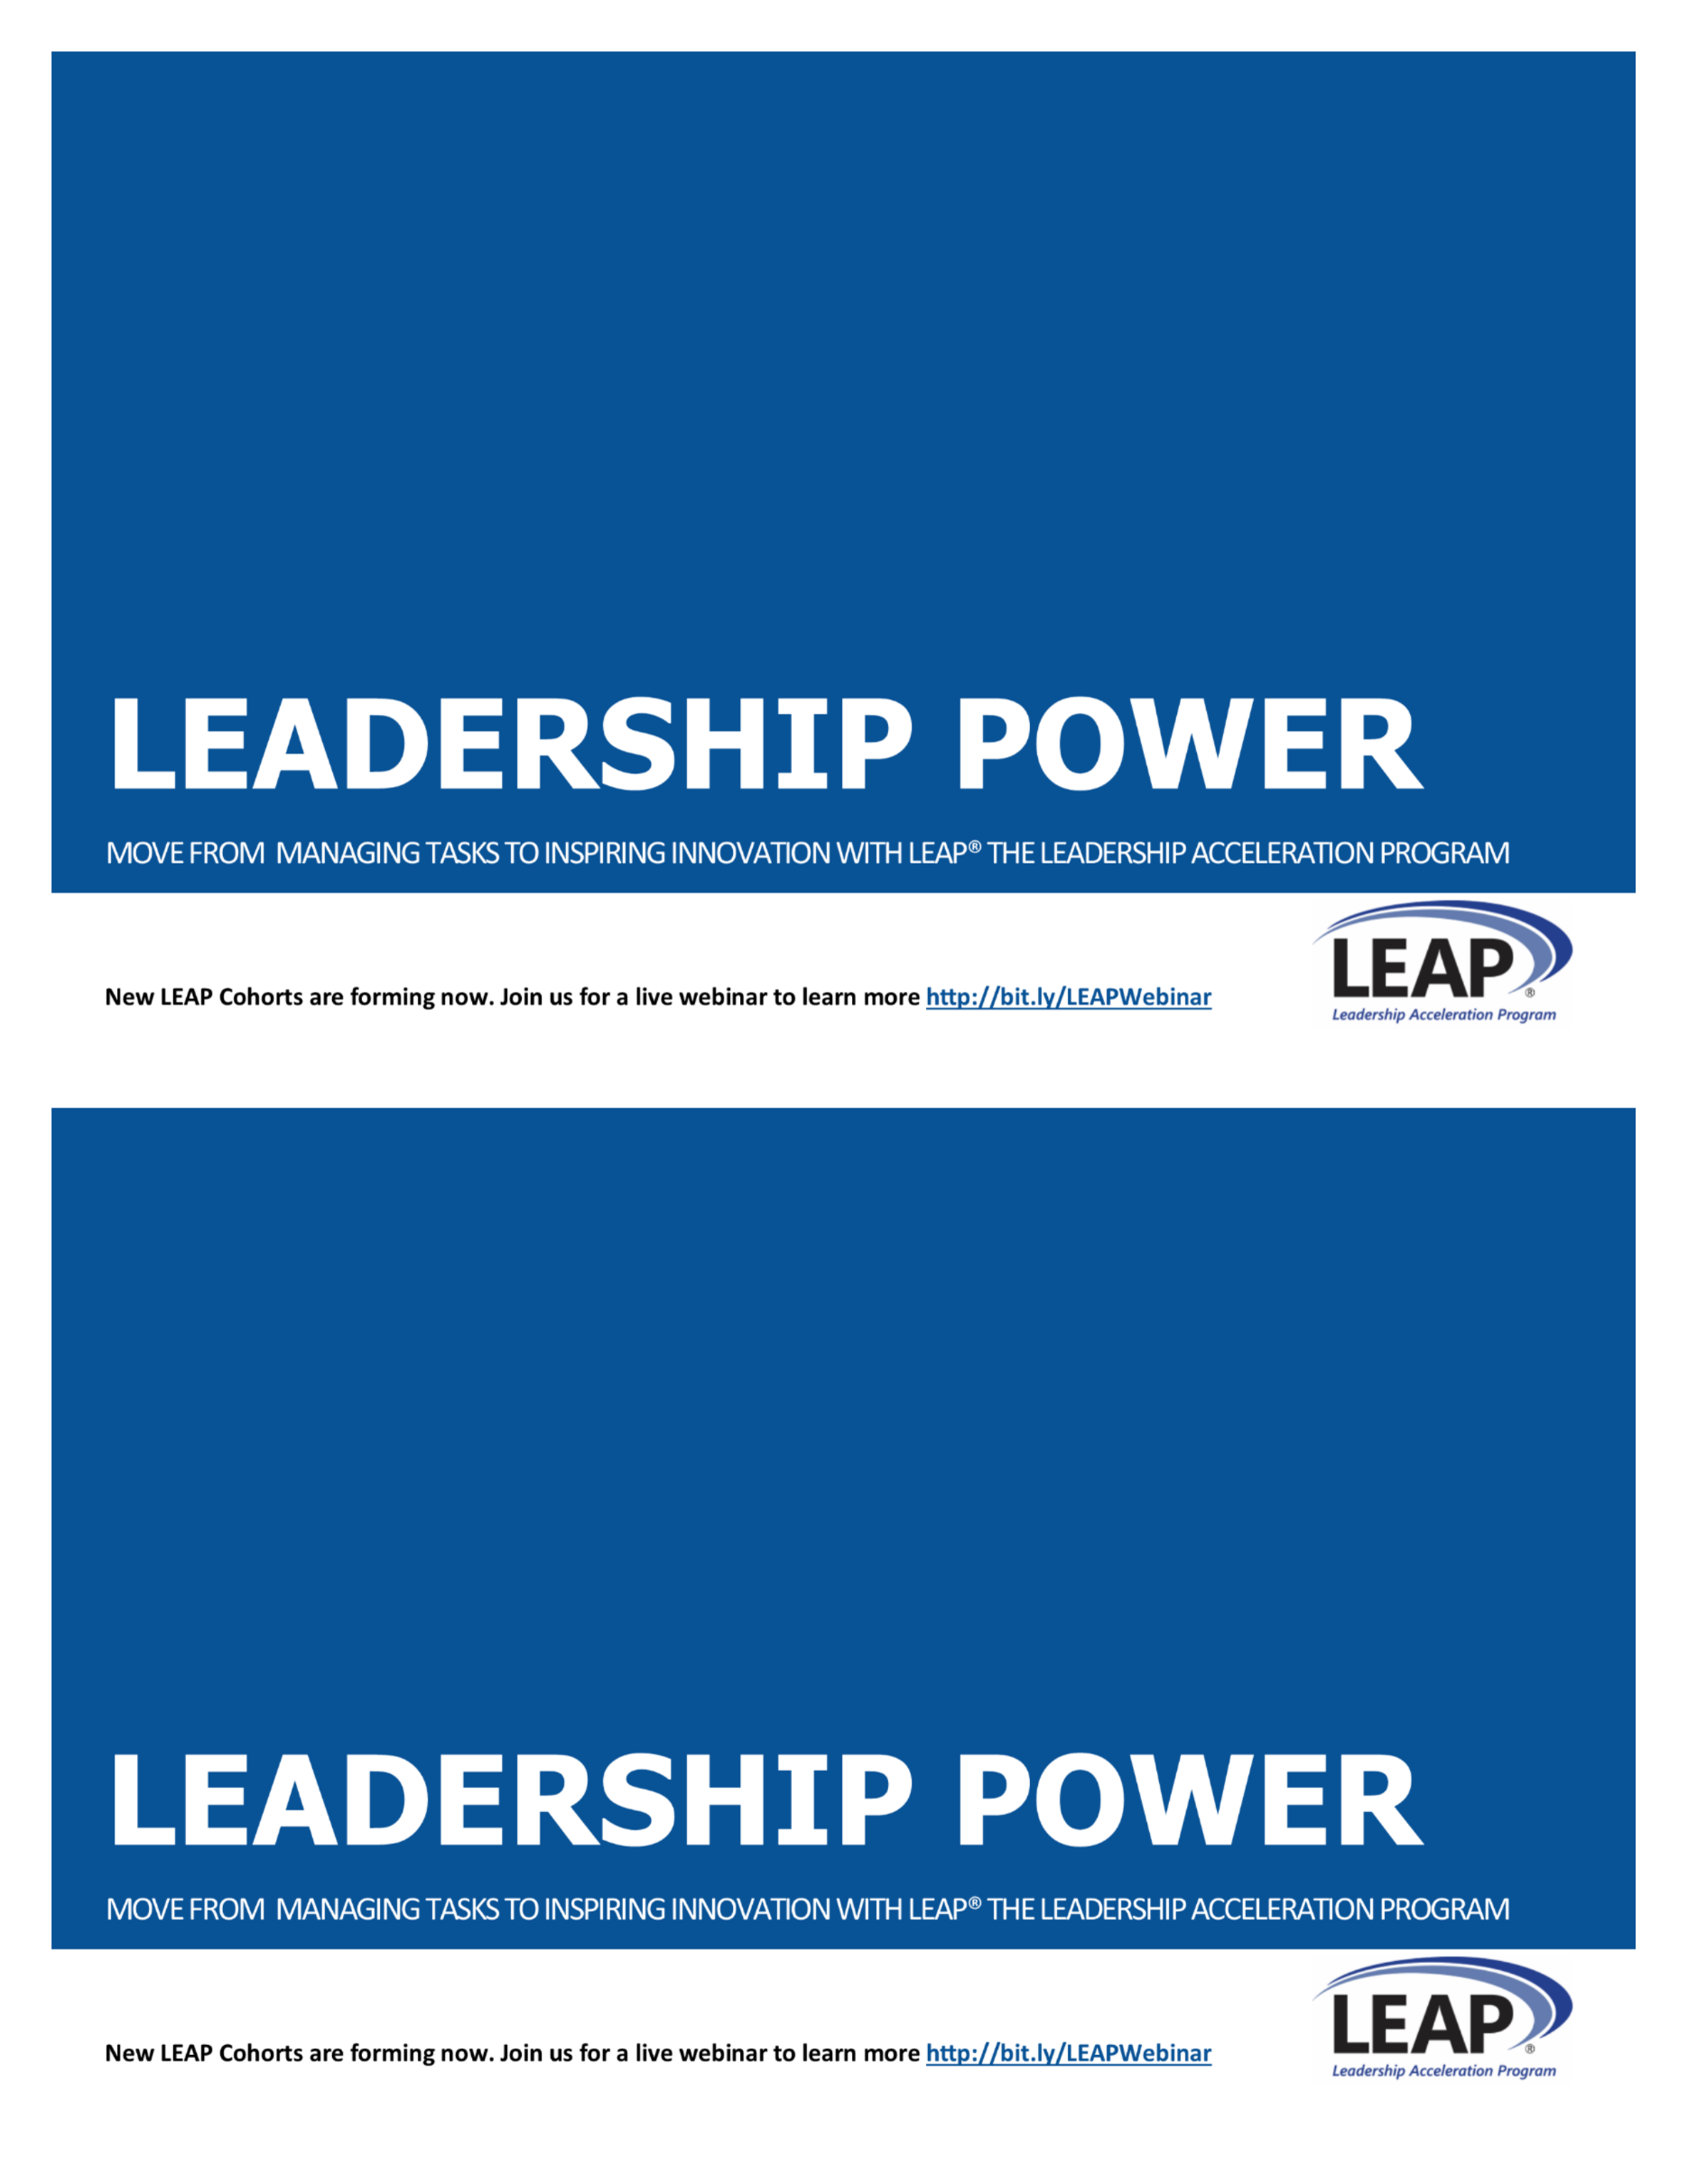

LEAP® LEADERSHIP DEVELOPMENT

Move from managing tasks to inspiring innovation by becoming a competent, confident leader.

Designed in 2002, specifically for small and mid-size businesses to develop their future leaders, LEAP® is the Leadership Acceleration Program to help sharpen your competitive edge and transform from mid-level manager into confident, competent leader. New LEAP Cohorts are forming now, contact me to find out how to get started.

**CONTACT: [LEAP COACH NAME]**

**[EMAIL]**

**[PHONE]**

**Or find out more at** [**www.xxx.com**](http://www.xxx.com)



LEAP® LEADERSHIP DEVELOPMENT

Move from managing tasks to inspiring innovation by becoming a competent, confident leader.

Designed in 2002, specifically for small and mid-size businesses to develop their future leaders, LEAP® is the Leadership Acceleration Program to help sharpen your competitive edge and transform from mid-level manager into confident, competent leader. New LEAP Cohorts are forming now, contact me to find out how to get started.

**CONTACT: [LEAP COACH NAME]**

**[EMAIL]**

**[PHONE]**

**Or find out more at** [**www.xxx.com**](http://www.xxx.com)



NAME

COMPANY NAME

ADDRESS

CITY, STATE ZIP

NAME

COMPANY NAME

ADDRESS

CITY, STATE ZIP