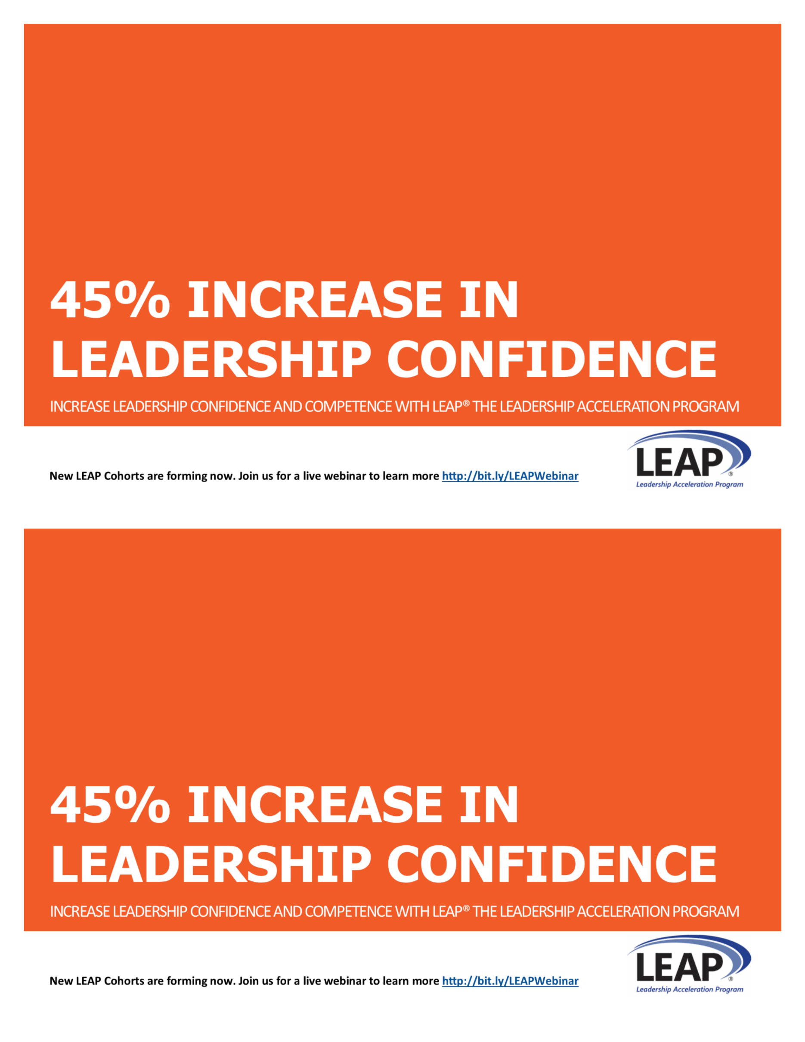

LEAP® LEADERSHIP DEVELOPMENT

With an increase in leadership confidence and competence employees solve problems faster, make better decisions, inspire others, and contribute innovative solutions.

Designed in 2002, specifically for mid-level managers, LEAP will increase leadership confidence and competence and transform managers into leaders who are capable of moving an organization to the next level.

**CONTACT:**

**[LEAP COACH NAME]**

**[EMAIL]**

**[PHONE]**

**Or find out more at** [**www.xxx.com**](http://www.xxx.com)



LEAP® LEADERSHIP DEVELOPMENT

With an increase in leadership confidence and competence employees solve problems faster, make better decisions, inspire others, and contribute innovative solutions.

Designed in 2002, specifically for mid-level managers, LEAP will increase leadership confidence and competence and transform managers into leaders who are capable of moving an organization to the next level.

**CONTACT:**

**[LEAP COACH NAME]**

**[EMAIL]**

**[PHONE]**

**Or find out more at** [**www.xxx.com**](http://www.xxx.com)



NAME

COMPANY NAME

ADDRESS

CITY, STATE ZIP

NAME

COMPANY NAME

ADDRESS

CITY, STATE ZIP