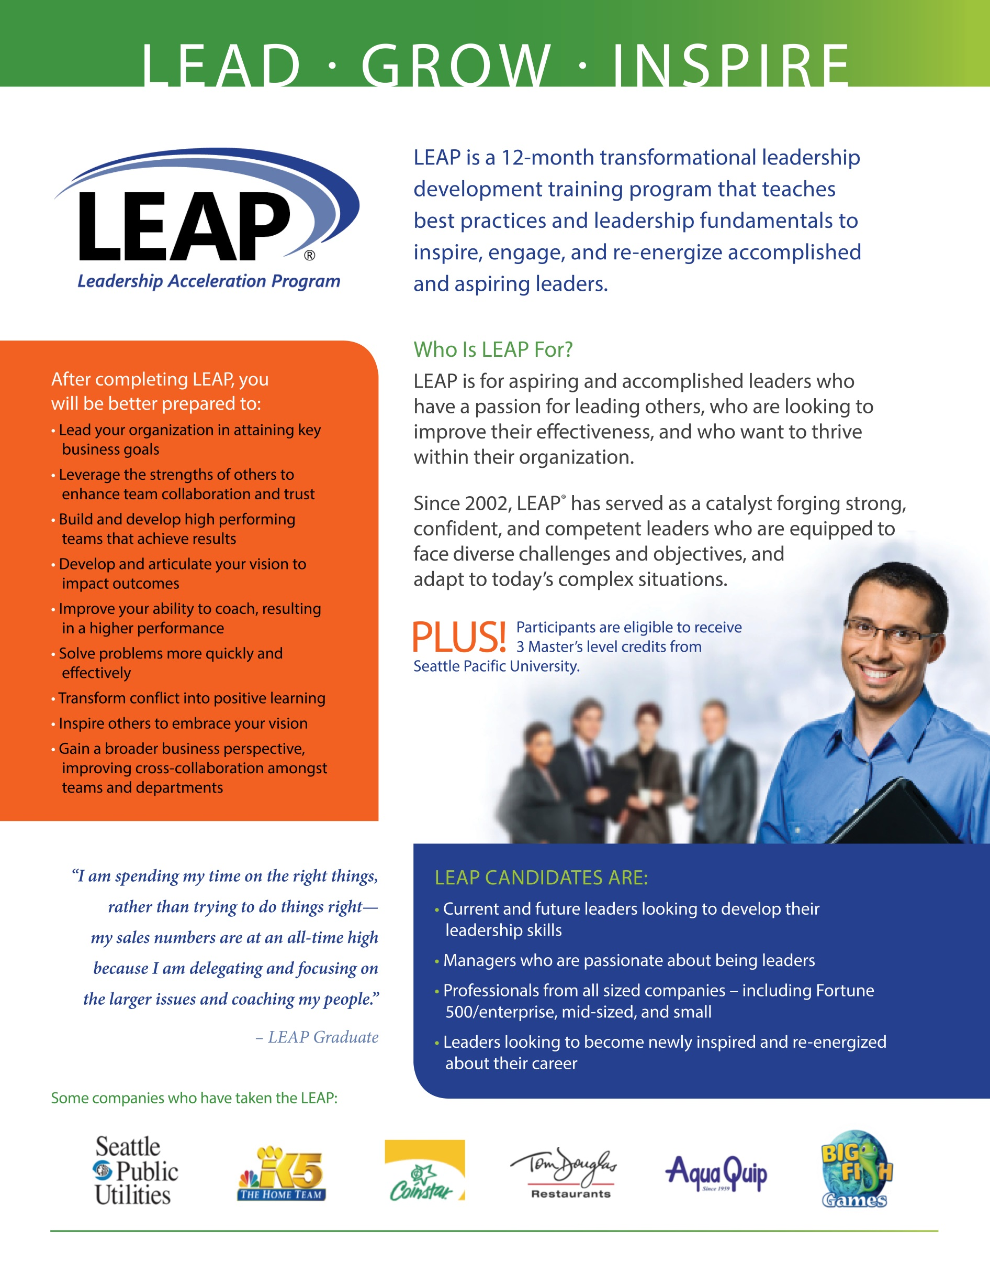



**<<Insert your client logos here>>**





**About YOU and YOUR COMPANY NAME:**

<<**Replace with your bio**>> Since 2002, *Founder & President* Lynda Silsbee and *Senior Consultant* Amanda Spraker have helped professionals of all levels develop profound leadership qualities. With more than 45 years of combined leadership, business management, executive coaching, and human resources experience, Lynda and Amanda have acquired best leadership practices and principles to help you reach new heights of achievement in your career. *Lynda and Amanda designed LEAP using leadership development practices employed by some of today’s most successful organizations to help inspire, engage, and re-energize both accomplished and aspiring leaders.*

**<< YOUR NAME HERE>>**

**<<your web page or:>>** [**www.pdgroup.net/LEAP**](http://www.pdgroup.net/LEAP)

**<<YOUR PHONE NUMBER>> | <<YOUR EMAIL>>**

**<<Insert your logo here>>**

**<<Insert your photo here>>**