LEAP RECRUITMENT POSTS

Move from managing tasks to inspiring innovation by becoming a competent, confident leader. Register for our October 21 webinar to learn how you can make the LEAP from manager to inspiring leader. http://bit.ly/LEAPWebinar
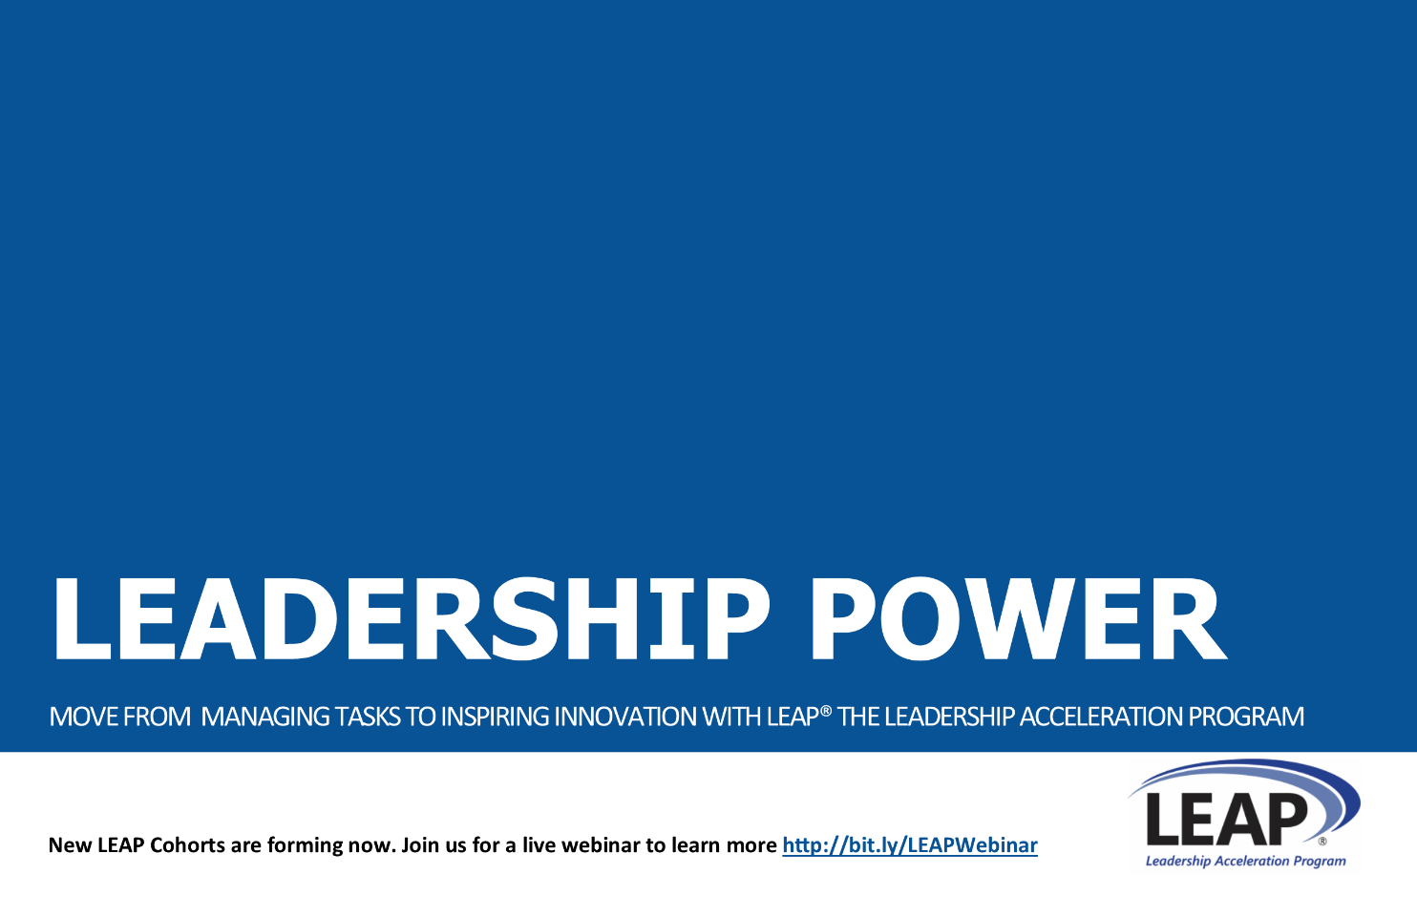

Accelerate execution in your organization. Competent, confident leaders at the mid-level are the key to successful strategy execution. Register for our webinar on October 21 to learn about LEAP® the Leadership Acceleration Program, specifically designed to transform mid-level managers into confident, competent leaders. http://bit.ly/LEAPWebinar
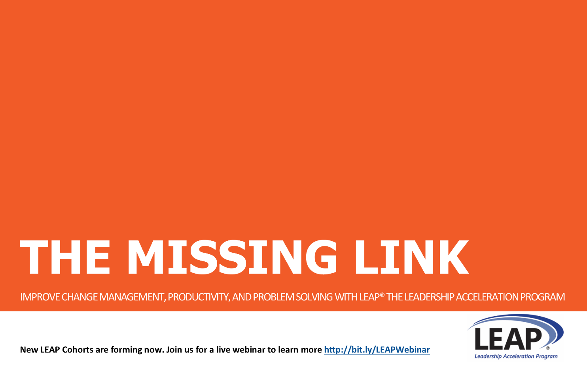

Does your organization have great strategy but struggle to execute well? You're not alone. Successful strategy execution tops the list of concerns for CEO's worldwide. Join us for a Harvard Business Review Executive Briefing breakfast on November 17. Register early to reserve your spot at the table https://execbrief-nov2015.eventbrite.com
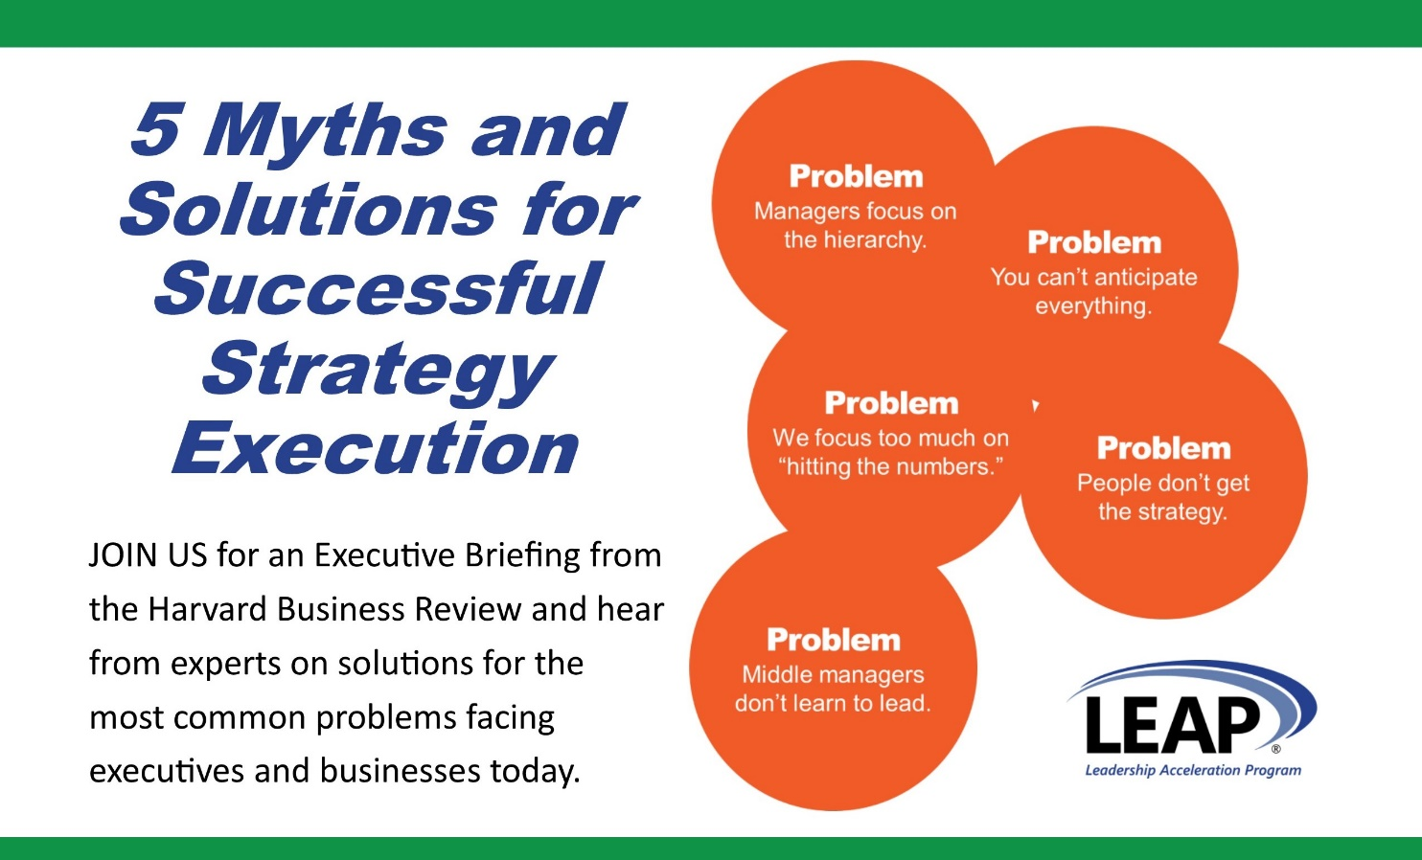

Have you been looking for a new way to LEAP to success? By increasing the leadership confidence and competence of your mid-level managers, you can transform your organization with new innovation, accelerated execution, and improved problem solving and results. Join us for a live webinar on October 21 to learn more about LEAP® the Leadership Acceleration Program for mid-level managers. http://bit.ly/LEAPWebinar
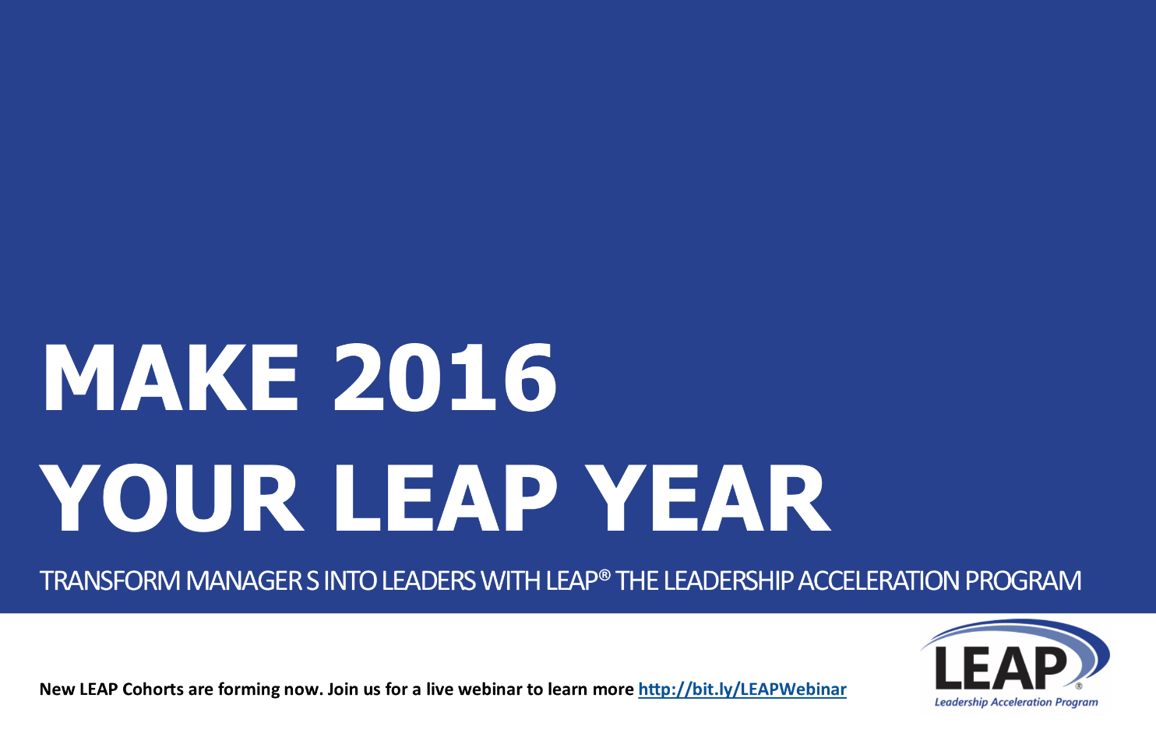

Spending in leadership development investment is on the rise. Confident, competent leaders can drive new innovation, accelerate strategy execution, and improve problem solving and results. Sharpen your competitive edge by investing in your mid-level managers to transform them into confident, competent leaders. Join us for a live webinar to learn about LEAP® the Leadership Acceleration Program. http://bit.ly/LEAPWebinar

What can you do with increased leadership confidence and competence? Innovate. Accelerate strategy execution. Improve problem solving and results. Our LEAP® Leadership Acceleration Program is designed to transform your mid-level managers into confident, competent leaders who can take your organization to the next level. Register to attend our webinar on October 21 at 9am Pacific http://bit.ly/LEAPWebinar
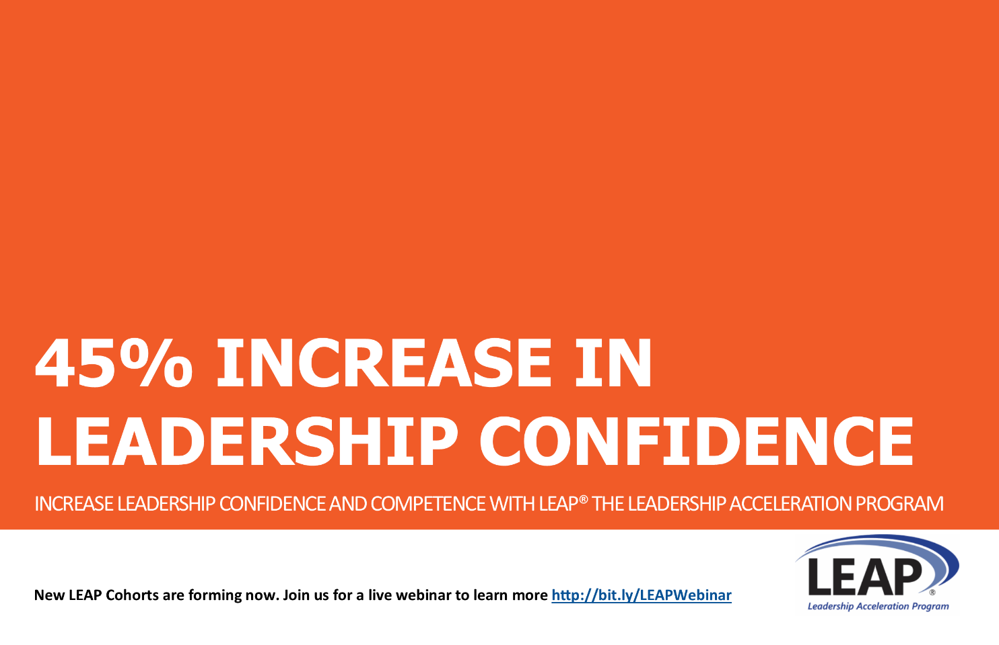

Does your organization struggle to develop new innovative solutions? Competent, confident leaders at the mid-level are the key to unlocking new innovation throughout your employee network. Invest in your mid-level and help them transform from managing tasks to inspiring innovation. Register to attend our webinar about LEAP® the Leadership Acceleration Program for mid-level managers http://bit.ly/LEAPWebinar
