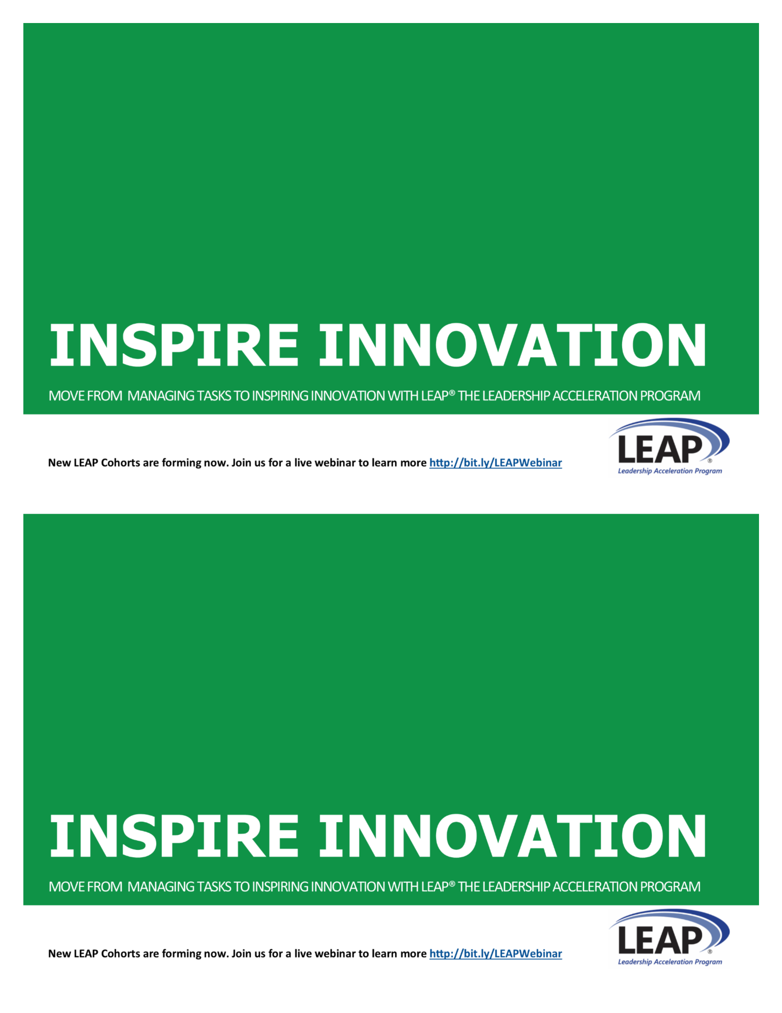

LEAP® LEADERSHIP DEVELOPMENT

Does your organization struggle to develop new innovative solutions? Competent, confident leaders at the mid-level are the key to unlocking new innovation throughout your employee network. Invest in your mid-level and help them transform from managing tasks to inspiring innovation.

Designed in 2002, specifically for small and mid-size businesses to develop their future leaders, LEAP will increase leadership confidence and competence and transform managers into leaders.

**CONTACT: [LEAP COACH NAME]**

**[EMAIL]**

**[PHONE]**

**Or find out more at** [**www.xxx.com**](http://www.xxx.com)



LEAP® LEADERSHIP DEVELOPMENT

Does your organization struggle to develop new innovative solutions? Competent, confident leaders at the mid-level are the key to unlocking new innovation throughout your employee network. Invest in your mid-level and help them transform from managing tasks to inspiring innovation.

Designed in 2002, specifically for small and mid-size businesses to develop their future leaders, LEAP will increase leadership confidence and competence and transform managers into leaders.

**CONTACT: [LEAP COACH NAME]**

**[EMAIL]**

**[PHONE]**

**Or find out more at** [**www.xxx.com**](http://www.xxx.com)



NAME

COMPANY NAME

ADDRESS

CITY, STATE ZIP

NAME

COMPANY NAME

ADDRESS

CITY, STATE ZIP