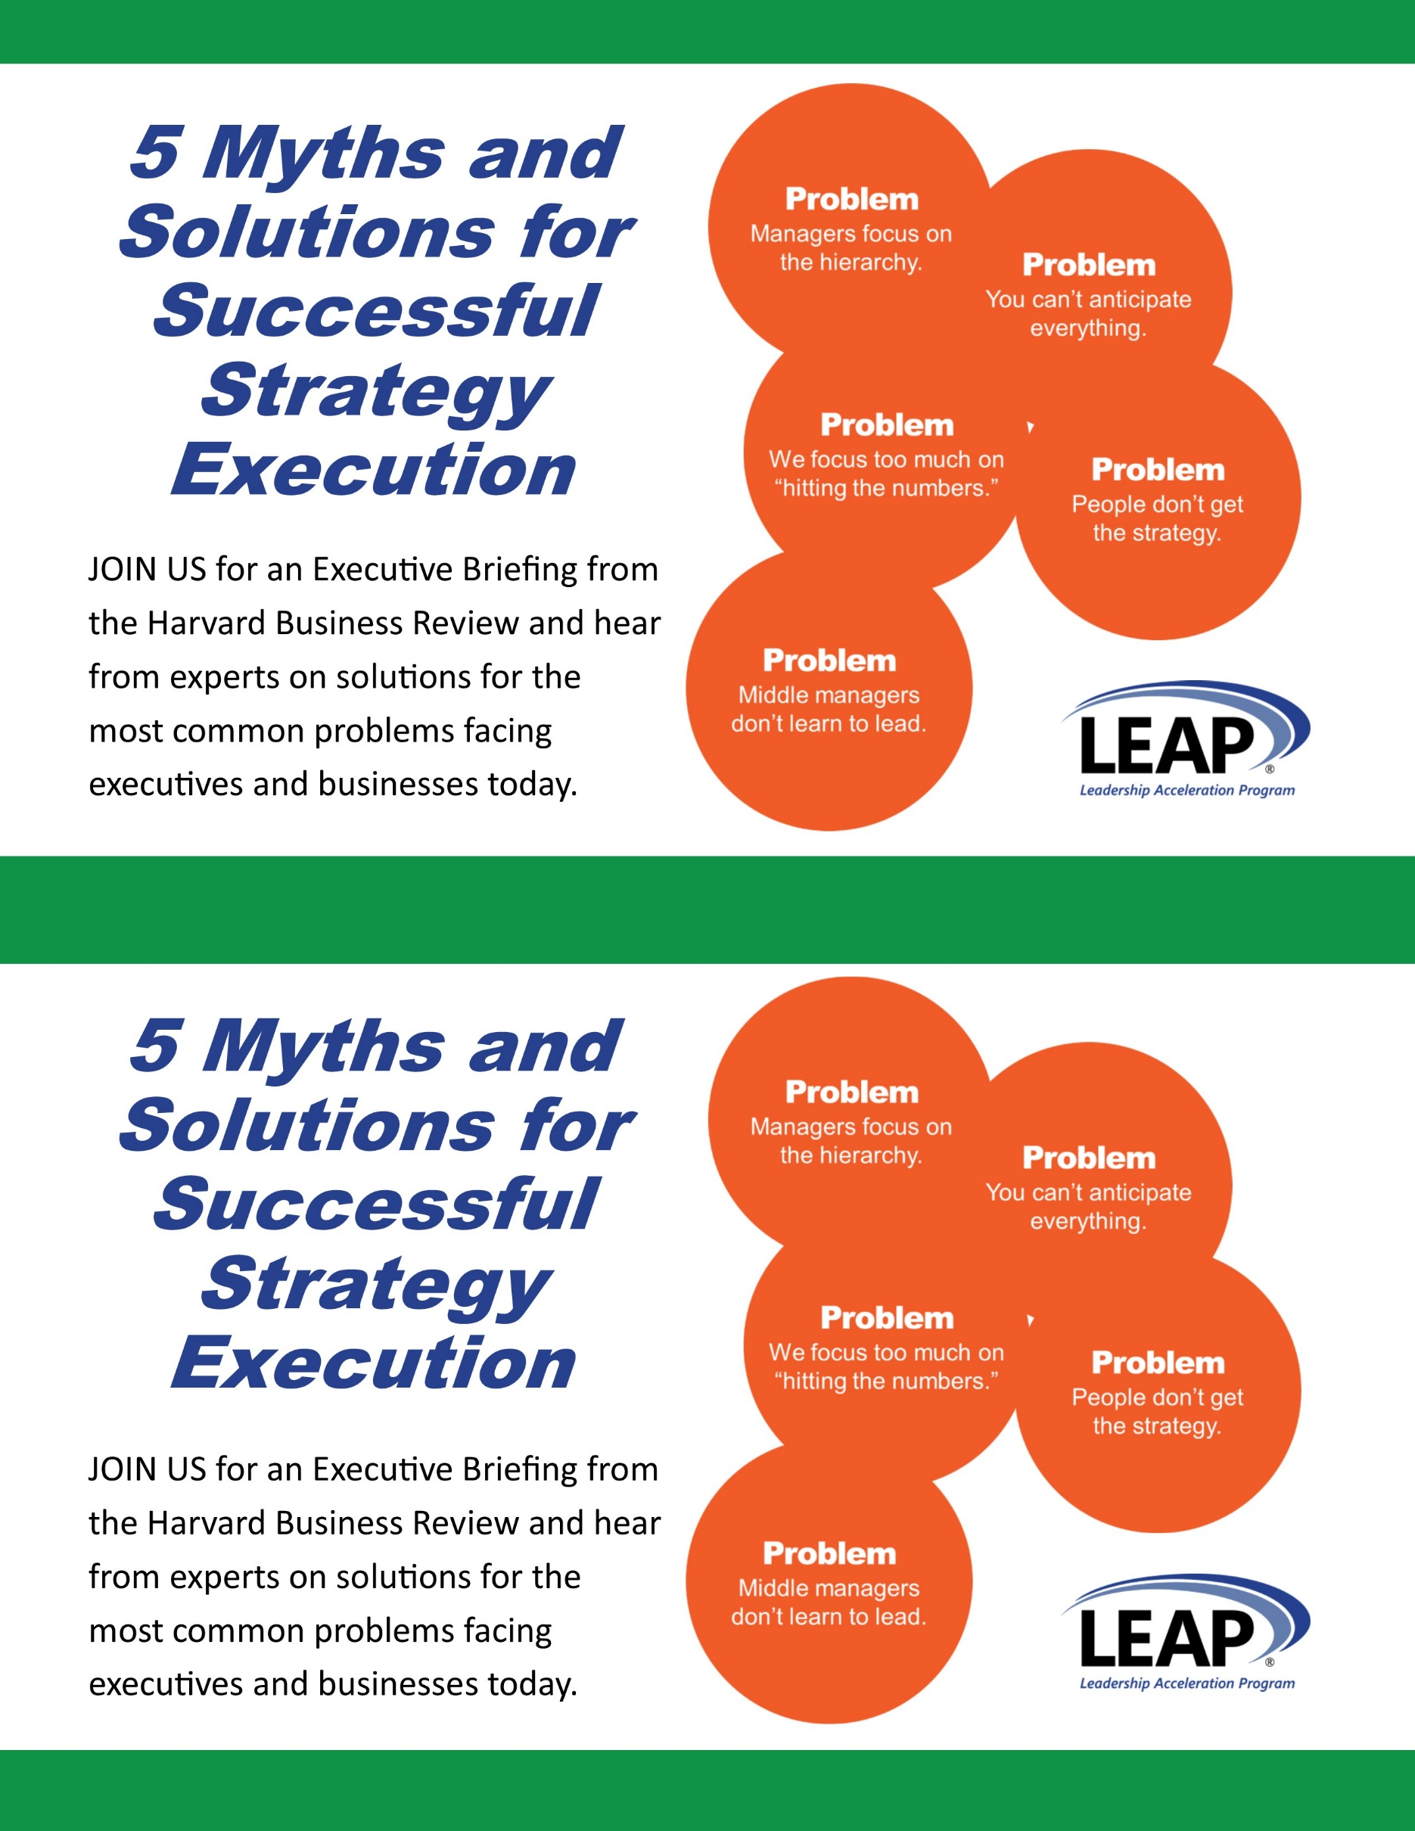

5 Solutions Executive Briefing

Since Michael Porter’s groundbreaking work in the 1980’s, we’ve gotten really good at developing strategy, but we’re not nearly as good at executing it. Studies show that up to ¾ of large organizations struggle to implement their strategies. When global CEOs are surveyed about their biggest concerns, execution tops the list—ahead of innovation, geopolitical instability, and top-line growth.

**DATE:**

**TIME:**

**LOCATION:**

**[EMAIL]**

**[PHONE]**

**Sign-Up at** [**www.xxx.com**](http://www.xxx.com)



5 Solutions Executive Briefing

Since Michael Porter’s groundbreaking work in the 1980’s, we’ve gotten really good at developing strategy, but we’re not nearly as good at executing it. Studies show that up to ¾ of large organizations struggle to implement their strategies. When global CEOs are surveyed about their biggest concerns, execution tops the list—ahead of innovation, geopolitical instability, and top-line growth.

**DATE:**

**TIME:**

**LOCATION:**

**[EMAIL]**

**[PHONE]**

**Sign-Up at** [**www.xxx.com**](http://www.xxx.com)



NAME

COMPANY NAME

ADDRESS

CITY, STATE ZIP

NAME

COMPANY NAME

ADDRESS

CITY, STATE ZIP